CLIMATE ANALYSE

TEMPERTURE

The mean annual temperature over Sri Lanka, which lies within latitudes 6 deg N and of approximately 10 deg N and longitudes of approximately 80 deg E and 82 deg E, is about 27.5 degC over the lowlands. The oceanic influence (the maximum width of the Island being only 225 kilometers) helps to reduce the temperature in lowlands by sea breeze. The highlands in the central region enjoy a cooler climate with a mean temperature of 18 deg C.

Temperature decreases at a steady rate of about 6.5 deg C for each 1,000 metre rise. Thus, at Kandy, which is 488 metres above mean sea level, the mean annual temperature is about 24.5 deg C; at Diyatalawa, (1,250 metres above mean sea level) the mean annual temperature is about 20.2 deg C, and at Nuwara-Eliya, where the elevation is 1895 metres, the mean annual temperature is about 15.8 deg C.

A noteworthy feature in many parts of Sri Lanka is the small variation in the mean monthly temperatures throughout the year. On average, the mean temperature of 25.0 deg C during the coolest months, November to February, is only 2.4 deg C lower than that during the warmest months April and May.

Higher temperatures are experienced generally in the Northern, North - central and Eastern regions of the Island and range between 33.3 deg C and 34.7 deg C, on average.

Lower temperatures are experienced during the early hours of the day, a little before dawn. Along the coast, these temperatures occur during December and January and range between 21.0 deg C and 24.2 deg C, on average. At NuwaraEliya the average maximum temperature is 22.8 deg C in April (highest) and the average minimum temperature is 9.4 deg C in January (lowest). The minimum temperature at NuwaraEliya falls below the freezing point (0 deg C) only very occasionally.

Diurnal variation of temperature, i.e., the rise to a maximum early in the afternoon and the fall to a minimum shortly before dawn, is well marked. Its magnitude depends on the season. There is a gradual increase in the range with altitude as well as with distance from the sea.

References - (<http://www.statistics.gov.lk/abstract2019/CHAP1>) (<https://www.ventusky.com/?p=7.516;80.912;9&l=temperature-2m&t=20210311/0600>)

RAINFALL

Annual 2540 mm to over 5080 mm in south west of the Island. Less than 1250 mm in the north west and south east of the Inland.

Rainy Seasons

· South West Monsoon- May to August

· North East Monsoon- November to February

Agriculture in the north and east suffers badly during the South-west Monsoon because the moisture bearing winds dry out as they descend over the Central Highlands, producing hot, during and often very strong winds. Thus June, July and August are almost totally rainless throughout the Dry Zone. For much of the time a strong, hot wind, called yalhulanga by the Sinhalese peasantry and kachchan by the Tamils, desiccates the land.

Nearby three quarters of Sri Lanka lies in what is widely known as the 'Dry Zone', comprising the northern half and the whole of the east of the country. Average annual rainfall in this region is generally between 1,200-1,800 mm. In comparison with many parts of Europe this may not seem unduly dry, but like much of SE India, virtually all of the region's rain falls in the 3 months of the north-east Monsoon between October and December. The rain often comes in relativity short but dramatic bursts. Habarana, for example, located in the Dry Zone between Polonnarywa and Anuradhapura received 1,240 mm (nearly 50") of rain in the 3 days around Christmas in 1975. These rains caused catastrophic floods right across the Dry Zone.

References - Burt, T. and Weerasinghe, K., 2021. *Rainfall Distributions in Sri Lanka in Time and Space: An Analysis Based on Daily Rainfall Data*. [online] Semanticscholar.org. Available at: <https://www.semanticscholar.org/paper/Rainfall-Distributions-in-Sri-Lanka-in-Time-and-An-Burt-Weerasinghe/f2e6d407f37ad7d7396519164d21449d0117251b/figure/1> [Accessed 2 March 2021].

Covid-19 pandemic situation

Lots of symptoms can be seen in a COVID-19 patients such as fever, dry cough, tiredness. In this situation most of the patients gets medicines to cure faster. Fever is a main symptom in this illness. CDC considers a person to have a fever when he or she has a measured temperature of 100.4° F (38° C) or greater, or feels warm to the touch, or gives a history of feeling feverish. Even though measured temperature is the preferred and most accurate method to determine fever, it is not always possible to take a person’s temperature. In certain situations, other methods of detecting a possible fever should be considered:

self-reported history of feeling feverish when a thermometer is not available or the ill person has taken medication that would lower the measured temperature.

the person feels warm to the touch

appearance of a flushed face, glassy eyes, or chills if it is not feasible to touch the person or if the person does not report feeling feverish.

The presence of fever suggests an infectious cause, but fever is not always present with an infection.

References - <https://www.cdc.gov/quarantine/air/reporting-deaths-illness/definitions-symptoms-reportable-illnesses.html>

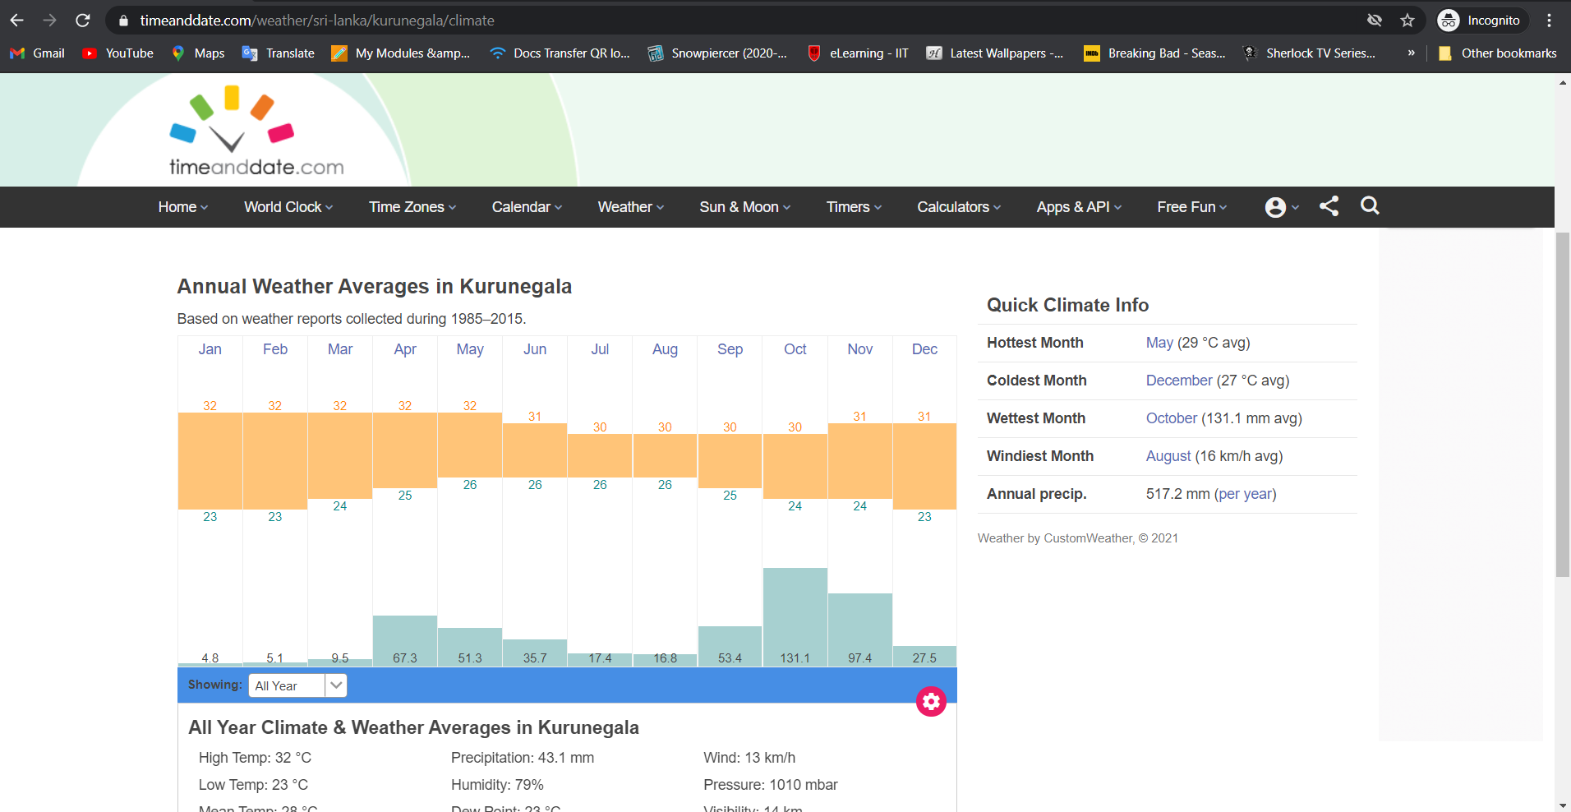

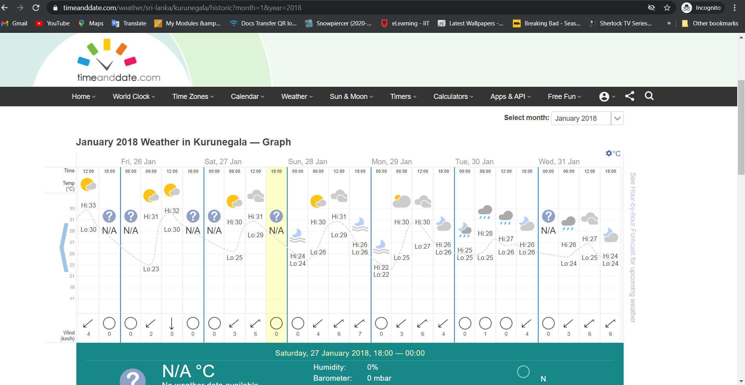

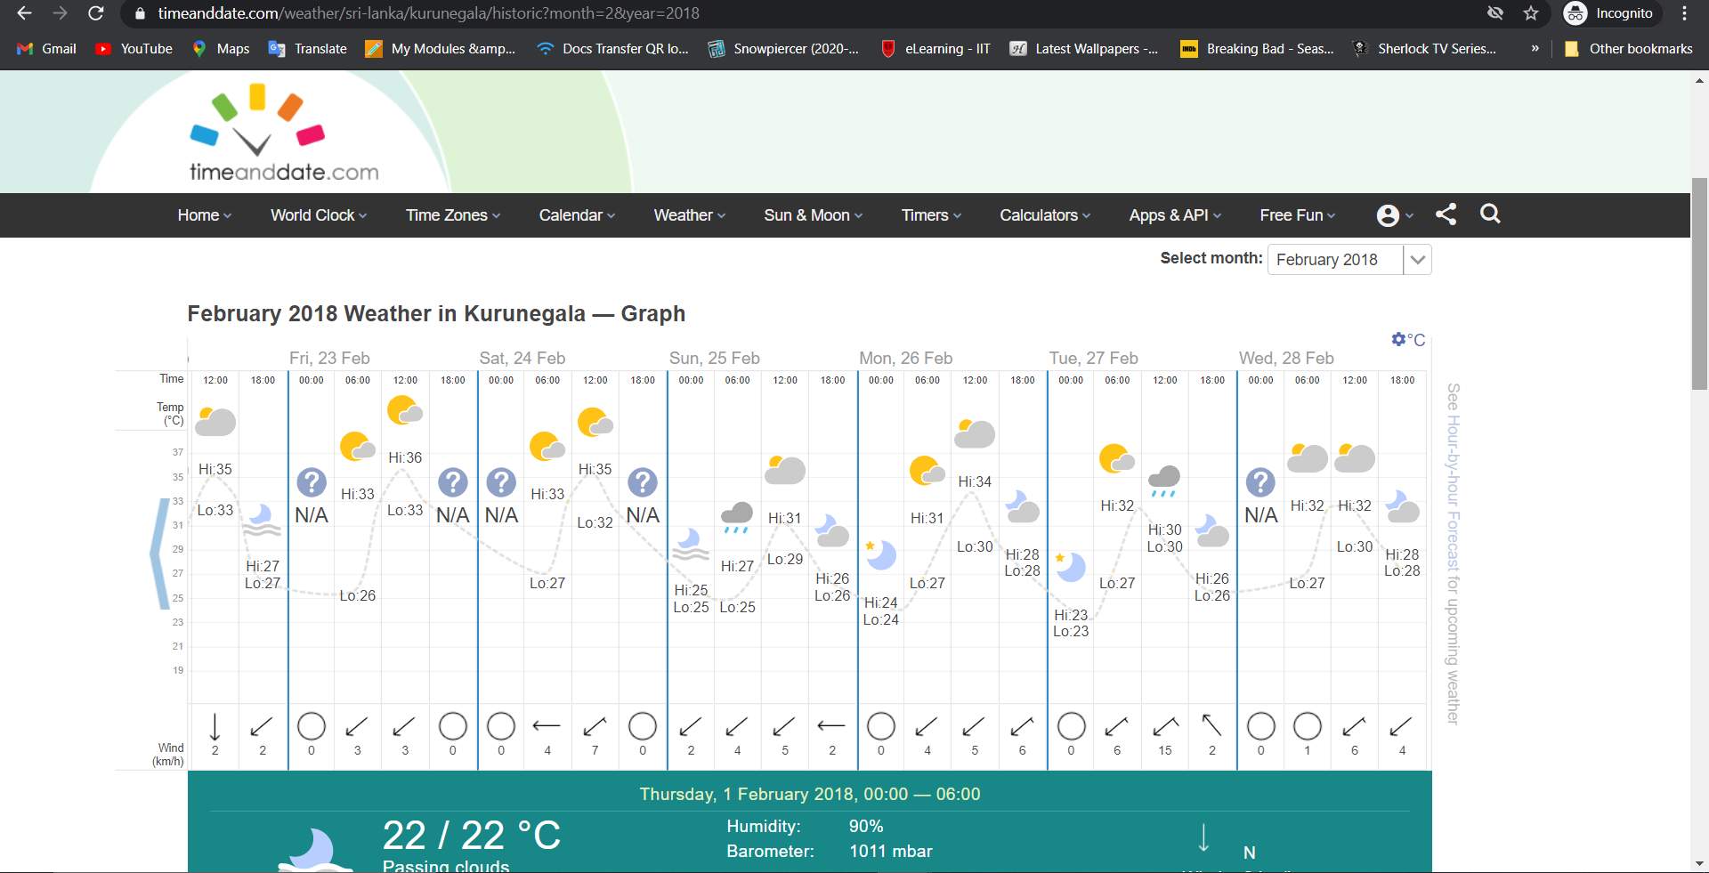

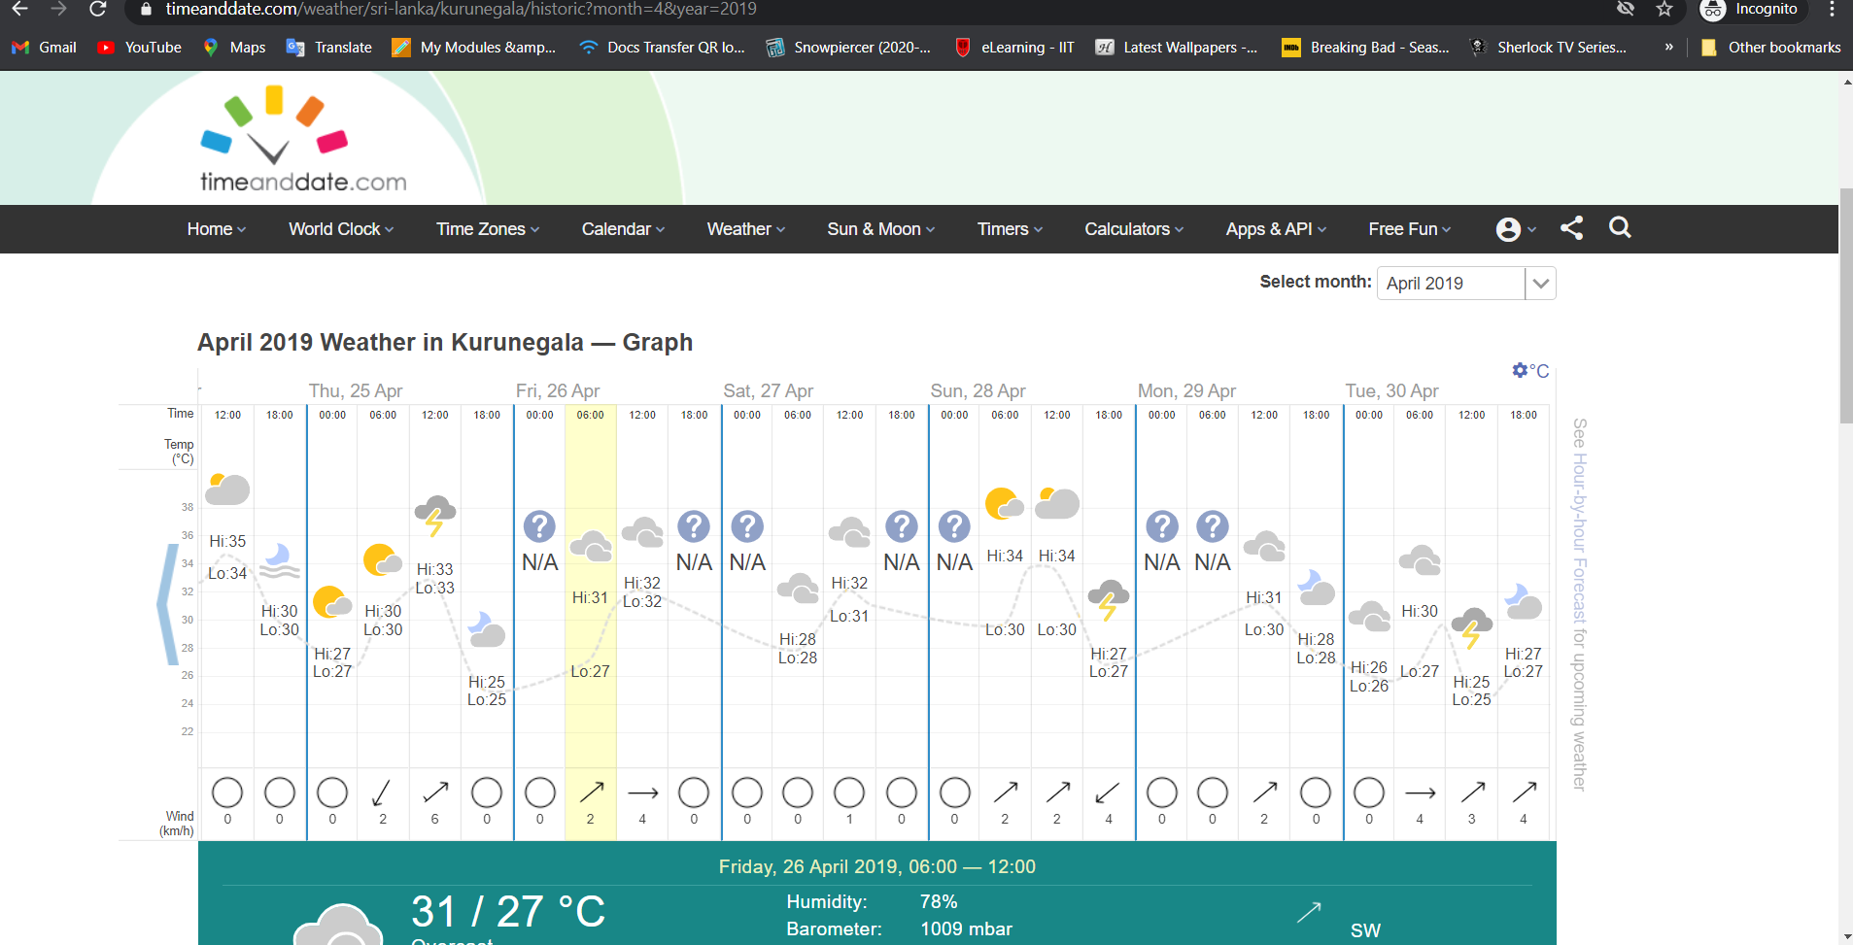

References - https://www.timeanddate.com/weather/sri-lanka/kurunegala/historic?month=5&year=2014

